**Tutorial-4 (Solutions)**

**Solution 1:** tan(45⁰)=(40+h)/70 → h=30 mm

**p΄**

**b**

h mm

40 mm

**Y**

**X**

**45⁰**

70 mm

**q΄**

**p**

**Solution 2:**

B

B

120⁰

30⁰

25 mm

b

**VP**

70 mm

a

Pivot end A

**HP**

**PP**

20 mm

a΄, b΄, v΄

55 mm

**Solution 3: Ans:** θ=24⁰ and Ф=41⁰

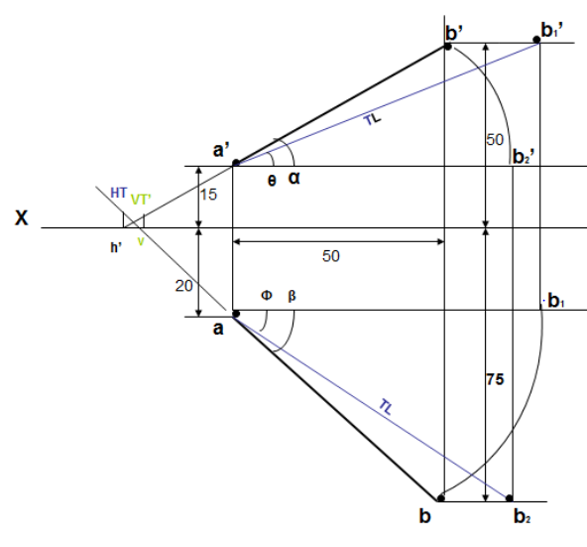

**Solution 4:**

